|  |  |  |  |  |  |  |  |  |  |  |
| --- | --- | --- | --- | --- | --- | --- | --- | --- | --- | --- |
|  | **CP1** | **(%)** | **CP2** | **(%)** | **CP3** | **(%)** | **CP4** | **(%)** | **CP5** | **(%)** |
| **COL** | 0.29 | 8.29 | 0.33 | 10.72 | -0.02 | 0.03 | -0.04 | 0.19 | 0.10 | 0.99 |
| **COT** | -0.28 | 7.57 | 0.29 | 8.69 | -0.07 | 0.42 | -0.17 | 2.77 | -0.07 | 0.53 |
| **DBO** | 0.34 | 11.27 | 0.22 | 4.79 | -0.03 | 0.09 | -0.06 | 0.38 | -0.05 | 0.24 |
| **DQO** | 0.19 | 3.44 | -0.10 | 1.09 | -0.24 | 5.56 | 0.41 | 17.21 | -0.34 | 11.78 |
| **DUR** | -0.02 | 0.04 | 0.18 | 3.10 | 0.54 | 28.73 | 0.22 | 4.77 | -0.12 | 1.38 |
| **NH3** | 0.20 | 4.11 | 0.08 | 0.59 | -0.12 | 1.43 | 0.52 | 27.32 | 0.06 | 0.36 |
| **NO2** | 0.16 | 2.71 | -0.43 | 18.66 | 0.06 | 0.37 | -0.24 | 5.61 | -0.01 | 0.00 |
| **NO3** | 0.02 | 0.06 | -0.48 | 22.61 | 0.07 | 0.47 | 0.03 | 0.07 | 0.04 | 0.17 |
| **NO** | 0.36 | 13.30 | 0.13 | 1.75 | -0.01 | 0.01 | -0.06 | 0.31 | 0.02 | 0.03 |
| **NT** | 0.38 | 14.35 | 0.01 | 0.02 | -0.01 | 0.01 | -0.01 | 0.01 | 0.07 | 0.56 |
| **NTOTK** | 0.15 | 2.35 | -0.41 | 16.60 | -0.03 | 0.09 | 0.11 | 1.24 | -0.24 | 5.53 |
| **OD** | -0.14 | 2.08 | -0.08 | 0.58 | -0.03 | 0.07 | 0.01 | 0.00 | 0.73 | 52.61 |
| **PO4** | 0.36 | 12.69 | 0.03 | 0.08 | -0.01 | 0.01 | -0.11 | 1.25 | 0.21 | 4.45 |
| **PT** | 0.35 | 12.49 | -0.11 | 1.31 | 0.04 | 0.14 | -0.09 | 0.86 | 0.18 | 3.21 |
| **PH** | -0.19 | 3.67 | -0.22 | 4.65 | 0.08 | 0.62 | 0.41 | 16.46 | 0.20 | 3.81 |
| **SDT** | 0.03 | 0.07 | 0.13 | 1.62 | 0.56 | 31.03 | 0.18 | 3.41 | -0.12 | 1.36 |
| **TEM** | 0.12 | 1.50 | -0.11 | 1.14 | 0.53 | 27.61 | -0.02 | 0.03 | 0.18 | 3.36 |
| **TUR** | -0.01 | 0.01 | -0.14 | 1.98 | 0.18 | 3.31 | -0.43 | 18.11 | -0.31 | 9.62 |
| **Eigenvalue** | 6.78 |  | 3.53 |  | 2.72 |  | 1.59 |  | 1.29 |  |
| **Variance (%)** | 37.68 |  | 19.63 |  | 15.14 |  | 8.86 |  | 7.18 |  |
| **Accumulated (%)** | 37.68 | 100.00 | 57.31 | 100.00 | 72.45 | 100.00 | 81.30 | 100.00 | 88.48 | 100.00 |

**Year 2013**

**Table 1. Weights of the Principal Components year 2013**

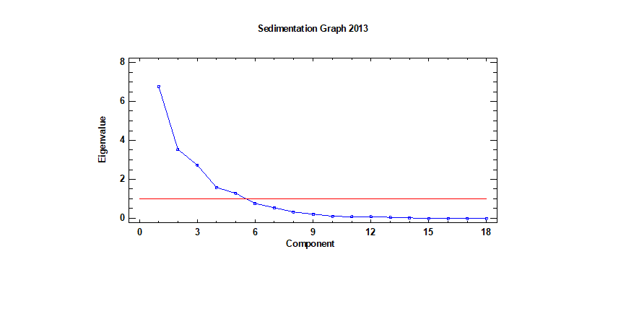



**Year 2014**

**Table 2. Weights of the Principal Components year 2014**

|  |  |  |  |  |  |  |  |  |  |  |
| --- | --- | --- | --- | --- | --- | --- | --- | --- | --- | --- |
|  | **CP1** | **(%)** | **CP2** | **(%)** | **CP3** | **(%)** | **CP4** | **(%)** | **CP5** | **(%)** |
| **COL** | 0.19 | 3.67 | 0.00 | 0.00 | -0.28 | 7.66 | 0.20 | 4.07 | -0.02 | 0.05 |
| **COT** | 0.08 | 0.57 | -0.33 | 10.60 | 0.02 | 0.04 | -0.12 | 1.53 | 0.55 | 30.04 |
| **DBO** | 0.18 | 3.14 | 0.10 | 1.03 | -0.52 | 26.68 | 0.16 | 2.49 | 0.09 | 0.73 |
| **DQO** | 0.11 | 1.29 | 0.27 | 7.29 | -0.10 | 0.91 | 0.33 | 10.91 | 0.27 | 7.11 |
| **DUR** | 0.01 | 0.00 | 0.47 | 21.90 | 0.05 | 0.29 | -0.04 | 0.14 | 0.00 | 0.00 |
| **NH3** | 0.26 | 6.95 | -0.11 | 1.27 | 0.14 | 1.84 | -0.17 | 2.82 | -0.51 | 26.47 |
| **NO2** | 0.35 | 12.31 | -0.15 | 2.16 | 0.08 | 0.60 | 0.14 | 1.87 | 0.01 | 0.01 |
| **NO3** | 0.29 | 8.31 | -0.04 | 0.18 | 0.36 | 13.16 | 0.11 | 1.32 | 0.30 | 9.06 |
| **NO** | 0.27 | 7.40 | 0.15 | 2.14 | -0.35 | 12.14 | 0.11 | 1.19 | -0.06 | 0.38 |
| **NT** | 0.38 | 14.74 | -0.07 | 0.45 | 0.10 | 1.02 | 0.00 | 0.00 | -0.04 | 0.12 |
| **NTOTK** | 0.33 | 11.07 | -0.06 | 0.32 | -0.21 | 4.26 | -0.13 | 1.57 | -0.37 | 13.42 |
| **OD** | -0.06 | 0.35 | -0.11 | 1.29 | 0.24 | 5.56 | 0.72 | 51.55 | -0.13 | 1.74 |
| **PO4** | 0.34 | 11.84 | 0.02 | 0.03 | 0.13 | 1.60 | -0.26 | 6.90 | 0.18 | 3.24 |
| **PT** | 0.36 | 13.17 | -0.06 | 0.37 | 0.05 | 0.22 | -0.12 | 1.36 | 0.16 | 2.72 |
| **PH** | 0.14 | 2.03 | 0.04 | 0.14 | 0.41 | 17.09 | 0.20 | 4.11 | -0.20 | 3.93 |
| **SDT** | 0.06 | 0.42 | 0.44 | 19.49 | 0.17 | 3.00 | -0.07 | 0.50 | -0.01 | 0.02 |
| **TEM** | 0.16 | 2.58 | 0.39 | 15.47 | 0.01 | 0.01 | 0.14 | 1.88 | 0.10 | 0.95 |
| **TUR** | -0.04 | 0.15 | 0.40 | 15.85 | 0.20 | 3.90 | -0.24 | 5.78 | 0.01 | 0.02 |
| **Eigenvalue** | 6.31 |  | 4.25 |  | 2.04 |  | 1.32 |  | 1.14 |  |
| **Variance (%)** | 35.06 |  | 23.61 |  | 11.35 |  | 7.35 |  | 6.31 |  |
| **Accumulated (%)** | 35.06 | 100.00 | 58.67 | 100.00 | 70.02 | 100.00 | 77.37 | 100.00 | 83.68 | 100.00 |

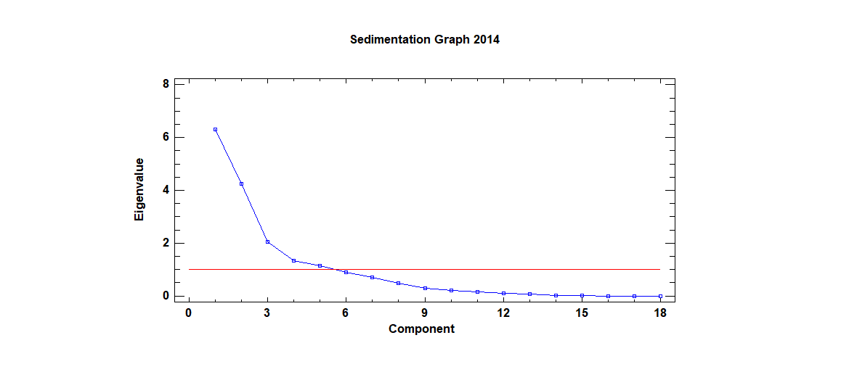





**Year 2015**

**Table 3. Weights of the Principal Components year 2015**

|  |  |  |  |  |  |  |  |  |  |  |
| --- | --- | --- | --- | --- | --- | --- | --- | --- | --- | --- |
|  | **CP1** | **(%)** | **CP2** | **(%)** | **CP3** | **(%)** | **CP4** | **(%)** | **CP5** | **(%)** |
| **COL** | 0.22 | 4.72 | -0.21 | 4.44 | -0.33 | 10.63 | -0.10 | 1.05 | -0.25 | 6.12 |
| **COT** | 0.29 | 8.31 | -0.15 | 2.28 | -0.04 | 0.13 | -0.22 | 4.72 | 0.14 | 2.09 |
| **DBO** | 0.18 | 3.34 | 0.21 | 4.28 | 0.45 | 20.05 | -0.08 | 0.67 | -0.31 | 9.41 |
| **DQO** | 0.22 | 4.92 | 0.01 | 0.01 | 0.39 | 15.21 | 0.37 | 13.38 | 0.19 | 3.61 |
| **DUR** | -0.03 | 0.08 | -0.40 | 15.75 | 0.30 | 8.89 | -0.22 | 4.80 | 0.01 | 0.01 |
| **NH3** | 0.15 | 2.39 | 0.36 | 13.03 | 0.20 | 3.97 | -0.24 | 5.65 | -0.17 | 2.98 |
| **NO2** | 0.33 | 11.19 | 0.18 | 3.34 | -0.10 | 0.95 | 0.01 | 0.02 | -0.09 | 0.86 |
| **NO3** | 0.31 | 9.87 | -0.13 | 1.72 | -0.17 | 3.03 | 0.02 | 0.05 | -0.14 | 1.95 |
| **NO** | 0.27 | 7.54 | 0.17 | 2.73 | 0.21 | 4.24 | 0.33 | 10.89 | 0.17 | 2.90 |
| **NT** | 0.34 | 11.73 | 0.16 | 2.62 | 0.11 | 1.19 | 0.08 | 0.62 | -0.05 | 0.27 |
| **NTOTK** | 0.24 | 5.60 | 0.00 | 0.00 | -0.42 | 18.02 | 0.26 | 6.51 | 0.22 | 4.88 |
| **OD** | -0.10 | 1.06 | -0.15 | 2.26 | -0.04 | 0.19 | 0.55 | 30.08 | -0.48 | 23.08 |
| **PO4** | 0.34 | 11.73 | 0.01 | 0.01 | -0.07 | 0.50 | -0.23 | 5.33 | -0.06 | 0.32 |
| **PT** | 0.35 | 12.14 | -0.02 | 0.05 | -0.11 | 1.28 | -0.08 | 0.70 | 0.14 | 2.10 |
| **PH** | 0.13 | 1.77 | -0.27 | 7.30 | 0.08 | 0.68 | 0.18 | 3.25 | -0.46 | 20.92 |
| **SDT** | 0.06 | 0.37 | -0.40 | 15.64 | 0.29 | 8.26 | -0.21 | 4.34 | 0.03 | 0.12 |
| **TEM** | 0.16 | 2.43 | -0.38 | 14.42 | 0.00 | 0.00 | -0.07 | 0.52 | -0.08 | 0.71 |
| **TUR** | 0.09 | 0.81 | -0.32 | 10.11 | 0.17 | 2.77 | 0.27 | 7.42 | 0.42 | 17.68 |
| **Eigenvalue** | 7.13 |  | 4.37 |  | 1.87 |  | 1.50862 |  | 1.20 |  |
| **Variance (%)** | 39.60 |  | 24.26 |  | 10.41 |  | 8.38 |  | 6.69 |  |
| **Accumulated (%)** | 39.60 | 100.00 | 63.86 | 100.00 | 74.27 | 100.00 | 82.65 | 100.00 | 89.34 | 100.00 |

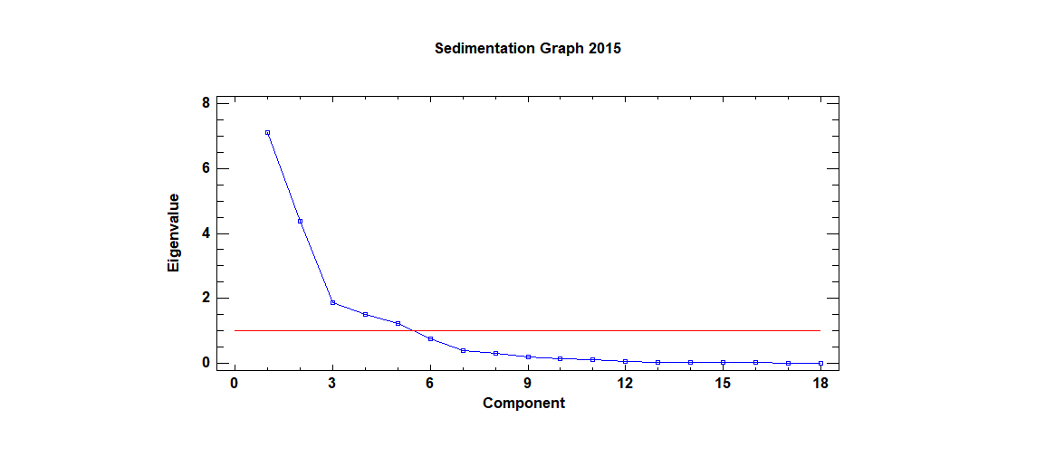





**Year 2016**

**Table 4. Weights of the Principal Components year 2016**

|  |  |  |  |  |  |  |  |  |  |  |
| --- | --- | --- | --- | --- | --- | --- | --- | --- | --- | --- |
|  | **CP1** | **(%)** | **CP2** | **(%)** | **CP3** | **(%)** | **CP4** | **(%)** | **CP5** | **(%)** |
| **COL** | 0.23 | 5.17 | 0.32 | 10.03 | -0.20 | 3.87 | 0.21 | 4.41 | 0.06 | 0.33 |
| **COT** | 0.18 | 3.29 | -0.10 | 0.93 | -0.37 | 13.67 | 0.02 | 0.04 | -0.44 | 19.18 |
| **DBO** | 0.24 | 5.76 | -0.15 | 2.32 | 0.38 | 14.33 | -0.16 | 2.63 | -0.22 | 4.99 |
| **DQO** | 0.24 | 5.97 | -0.08 | 0.64 | 0.35 | 11.92 | -0.11 | 1.17 | -0.08 | 0.63 |
| **DUR** | 0.02 | 0.06 | 0.44 | 19.41 | 0.14 | 1.89 | -0.07 | 0.54 | -0.19 | 3.50 |
| **NH3** | 0.30 | 9.11 | -0.22 | 4.89 | 0.19 | 3.62 | -0.04 | 0.18 | 0.24 | 5.77 |
| **NO2** | 0.32 | 9.99 | -0.15 | 2.15 | -0.24 | 5.97 | 0.17 | 2.86 | 0.05 | 0.27 |
| **NO3** | 0.30 | 9.04 | 0.07 | 0.53 | -0.30 | 8.89 | -0.04 | 0.14 | 0.08 | 0.66 |
| **NO** | 0.23 | 5.27 | 0.01 | 0.00 | 0.32 | 9.95 | -0.35 | 11.95 | -0.05 | 0.21 |
| **NT** | 0.38 | 14.38 | -0.06 | 0.35 | 0.06 | 0.30 | -0.15 | 2.32 | 0.11 | 1.28 |
| **NTOTK** | 0.22 | 5.05 | 0.08 | 0.68 | 0.09 | 0.84 | 0.48 | 23.23 | 0.37 | 13.65 |
| **OD** | -0.07 | 0.53 | 0.16 | 2.60 | -0.22 | 4.84 | -0.57 | 32.31 | 0.42 | 17.43 |
| **PO4** | 0.31 | 9.77 | -0.05 | 0.27 | -0.26 | 6.96 | -0.20 | 3.96 | -0.12 | 1.47 |
| **PT** | 0.35 | 12.52 | 0.01 | 0.00 | -0.11 | 1.12 | 0.01 | 0.01 | 0.15 | 2.33 |
| **PH** | -0.01 | 0.02 | 0.42 | 17.26 | -0.08 | 0.65 | -0.20 | 3.82 | 0.23 | 5.27 |
| **SDT** | 0.09 | 0.73 | 0.43 | 18.17 | 0.12 | 1.37 | -0.10 | 1.10 | -0.13 | 1.60 |
| **TEM** | 0.16 | 2.61 | 0.34 | 11.53 | -0.03 | 0.09 | 0.08 | 0.71 | -0.44 | 18.98 |
| **TUR** | 0.09 | 0.74 | 0.29 | 8.23 | 0.31 | 9.71 | 0.29 | 8.63 | 0.16 | 2.45 |
| **Eigenvalue** | 6.22 |  | 4.46 |  | 2.72 |  | 1.59 |  | 1.04 |  |
| **Variance (%)** | 34.55 |  | 24.79 |  | 15.13 |  | 8.81 |  | 5.78 |  |
| **Accumulated (%)** | 34.55 | 100.00 | 59.34 | 100.00 | 74.47 | 100.00 | 83.28 | 100.00 | 89.06 | 100.00 |

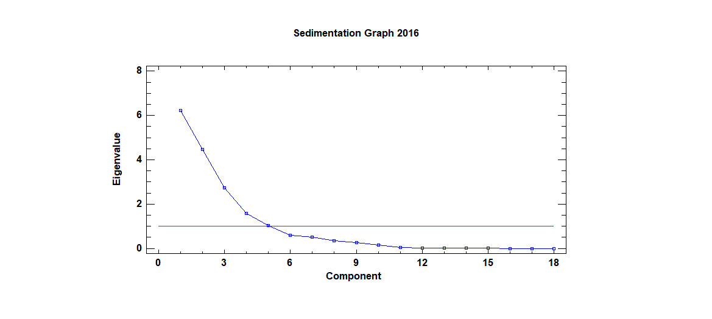





Year 2017

**Table 5. Weights of the Principal Components year 2017**

|  |  |  |  |  |  |  |  |  |
| --- | --- | --- | --- | --- | --- | --- | --- | --- |
|  | **CP1** | **(%)** | **CP2** | **(%)** | **CP3** | **(%)** | **CP4** | **(%)** |
| **COL** | 0.13 | 1.74 | 0.24 | 5.61 | -0.34 | 11.27 | -0.08 | 0.61 |
| **COT** | 0.08 | 0.69 | -0.25 | 6.01 | -0.29 | 8.29 | -0.11 | 1.25 |
| **DBO** | 0.09 | 0.85 | 0.24 | 5.88 | -0.43 | 18.27 | 0.24 | 5.63 |
| **DQO** | 0.15 | 2.25 | 0.14 | 1.96 | -0.38 | 14.68 | 0.13 | 1.57 |
| **DUR** | -0.08 | 0.71 | 0.38 | 14.53 | 0.27 | 7.42 | -0.19 | 3.45 |
| **N_NH3** | 0.34 | 11.89 | -0.17 | 2.74 | 0.08 | 0.67 | -0.18 | 3.16 |
| **N_NO2** | 0.32 | 9.99 | -0.08 | 0.59 | 0.05 | 0.28 | 0.41 | 16.65 |
| **N_NO3** | 0.35 | 12.00 | 0.05 | 0.21 | 0.17 | 2.73 | 0.15 | 2.34 |
| **NO** | 0.32 | 10.06 | 0.11 | 1.27 | -0.11 | 1.24 | -0.32 | 10.15 |
| **N_TOT** | 0.40 | 15.95 | -0.04 | 0.13 | 0.08 | 0.66 | -0.06 | 0.35 |
| **N_TOTK** | 0.37 | 13.54 | -0.08 | 0.59 | 0.01 | 0.02 | -0.25 | 6.38 |
| **OD** | -0.09 | 0.75 | 0.31 | 9.78 | -0.16 | 2.51 | -0.31 | 9.61 |
| **ORTO_PO4** | 0.18 | 3.11 | 0.16 | 2.50 | 0.23 | 5.41 | 0.45 | 20.11 |
| **P_TOT** | 0.38 | 14.55 | -0.02 | 0.05 | 0.15 | 2.11 | -0.14 | 1.95 |
| **PH** | 0.08 | 0.69 | 0.35 | 11.92 | 0.16 | 2.42 | -0.18 | 3.25 |
| **SDT** | -0.03 | 0.10 | 0.38 | 14.79 | 0.29 | 8.47 | -0.14 | 2.07 |
| **TEM** | 0.03 | 0.09 | 0.34 | 11.44 | 0.14 | 1.97 | 0.33 | 10.82 |
| **TUR** | 0.10 | 1.04 | 0.32 | 10.02 | -0.34 | 11.59 | 0.08 | 0.64 |
| **Eigenvalue** | 6.03 |  | 4.13 |  | 3.05 |  | 1.88 |  |
| **Variance (%)** | 33.51 |  | 22.93 |  | 16.94 |  | 10.42 |  |
| **Accumulated (%)** | 33.51 | 100.00 | 56.43 | 100.00 | 73.37 | 100.00 | 83.78 | 100.00 |

